**Lab 1: Imaging and Recovering Files**

**R. Harini**

**18BCE1010**

1. **Using AccessData FTK Imager**

**Procedure:**

Delete a File from the folder that needs to be recovered later. In this case, delete “Blogging.docx”

Create an image of the folder using FTK Imager

File -> Create Disk Image -> Select Source -> Contents of a Folder -> Enter Image Source Path of the Folder -> Add in Image Destination -> Enter Image Destination Folder and File Name -> Finish -> Start

Using RecoverMyFiles, recover deleted file from the Image

**Screenshots:**

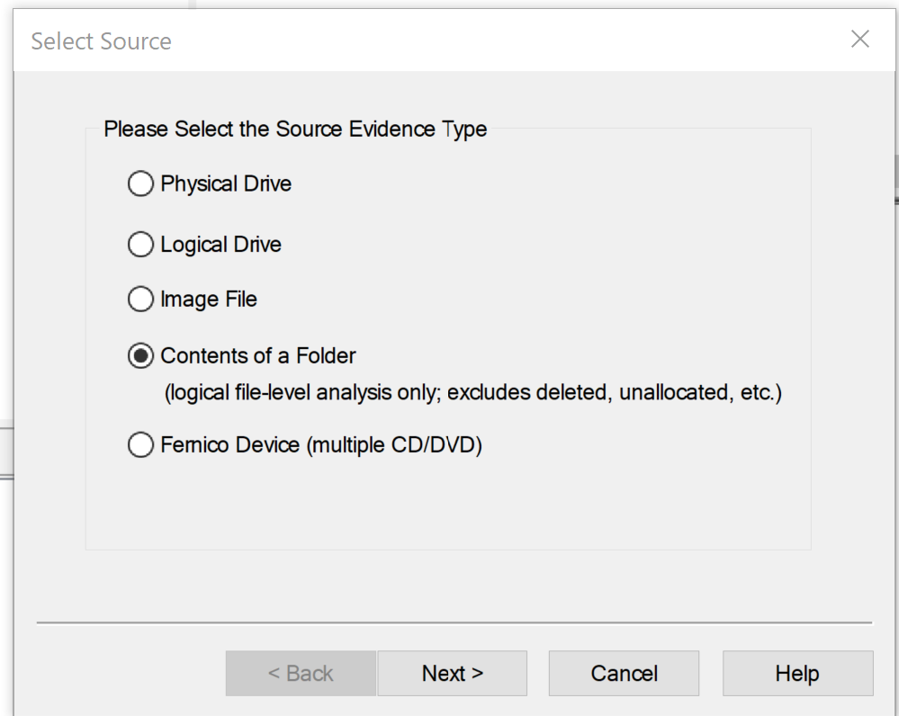

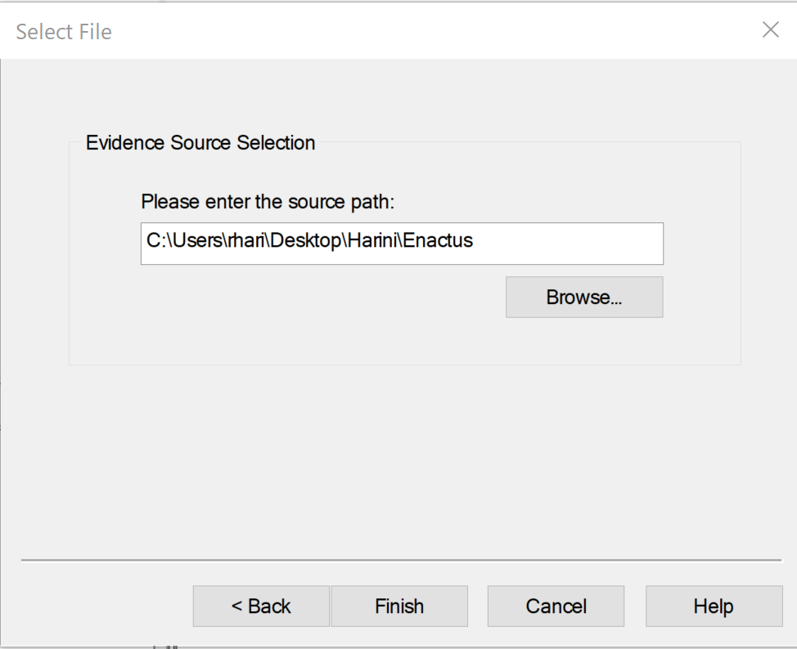

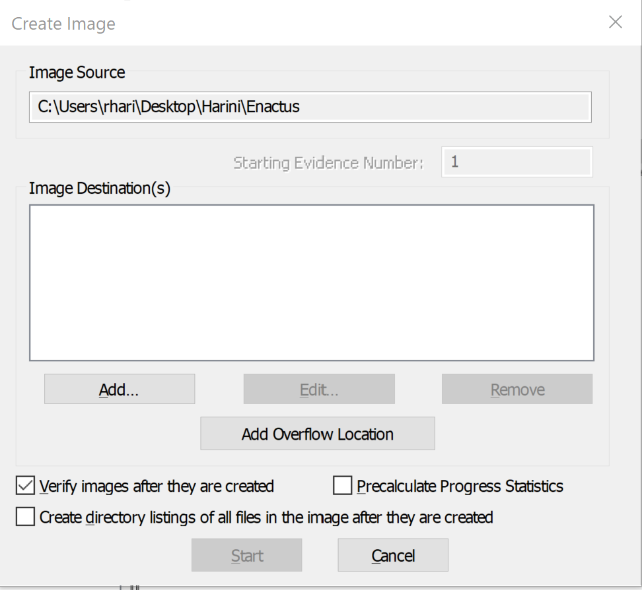

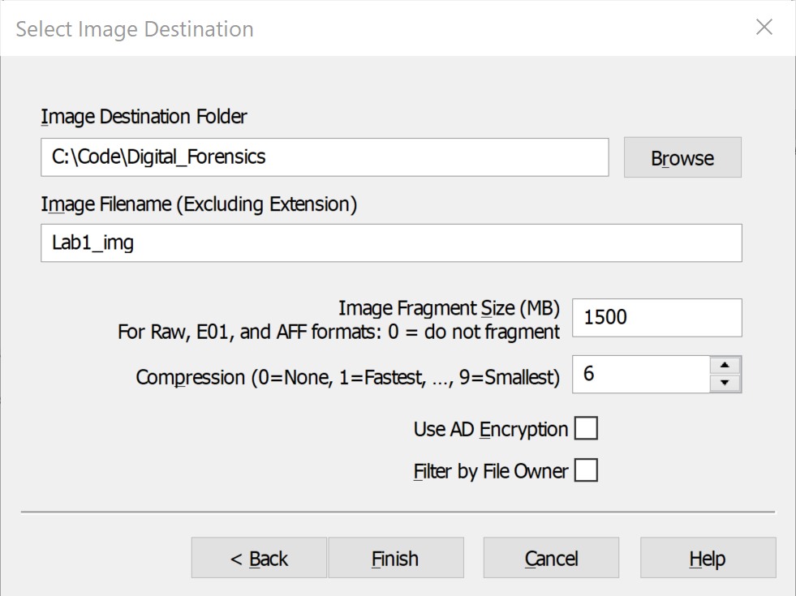

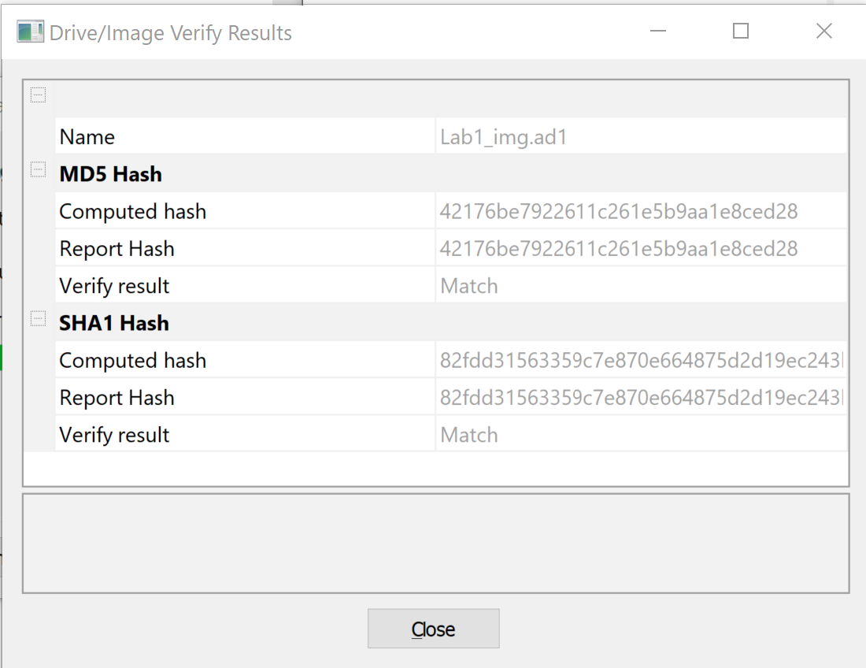

1. **Using RecoverMyFiles tool**

**Procedure:**

Recover Files -> Add Image -> Select the Image file created earlier -> Press Next

Under File List, you can view all the files inside the folder that were deleted.

**Outputs:**

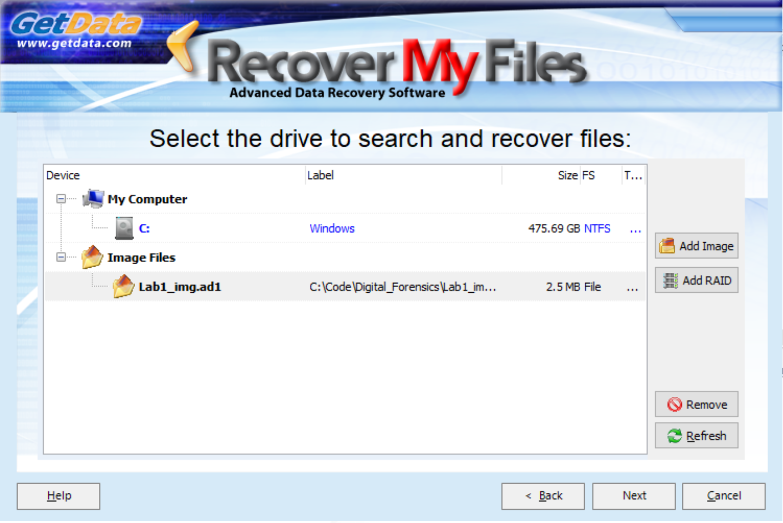

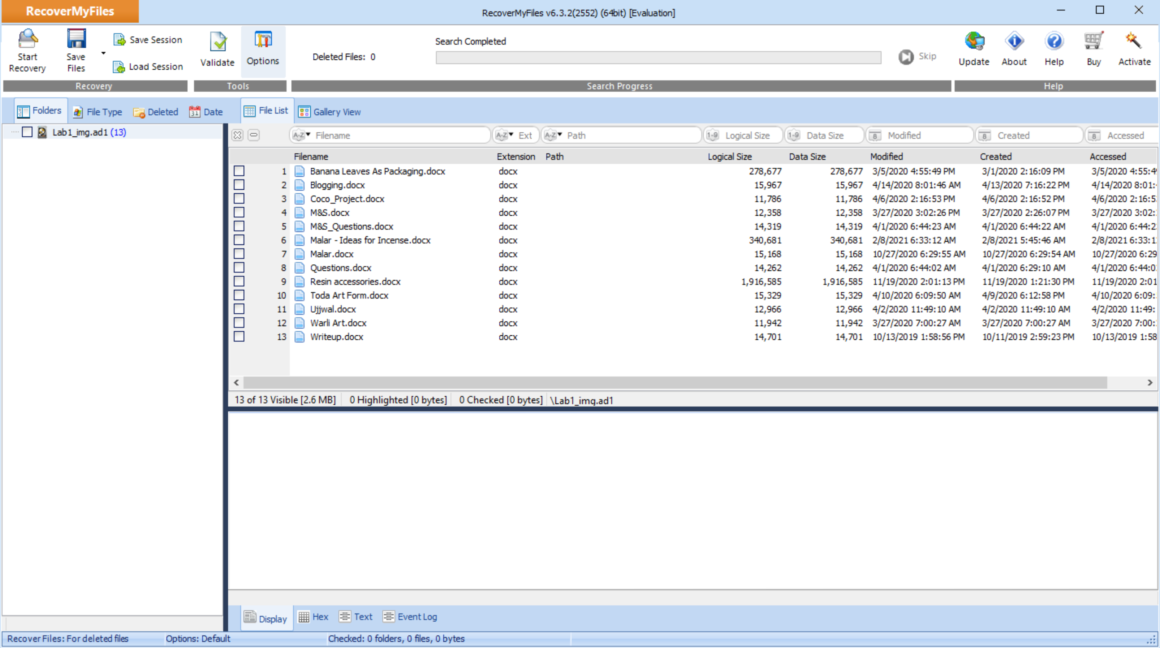

**Lab 2: Integrity Checking**

**R. Harini**

**18BCE1010**

**Aim:** To check the integrity of the files with the help of Hash Values

**Procedure:** Upload the File onto the website [MD5 File - HTML5 File Hash Online Calculator - MD5, SHA1, SHA2 (SHA-256), SHA-384, SHA-512](https://md5file.com/calculator) and calculate the Hash Values

**Outputs:**

1. **Original PowerPoint**

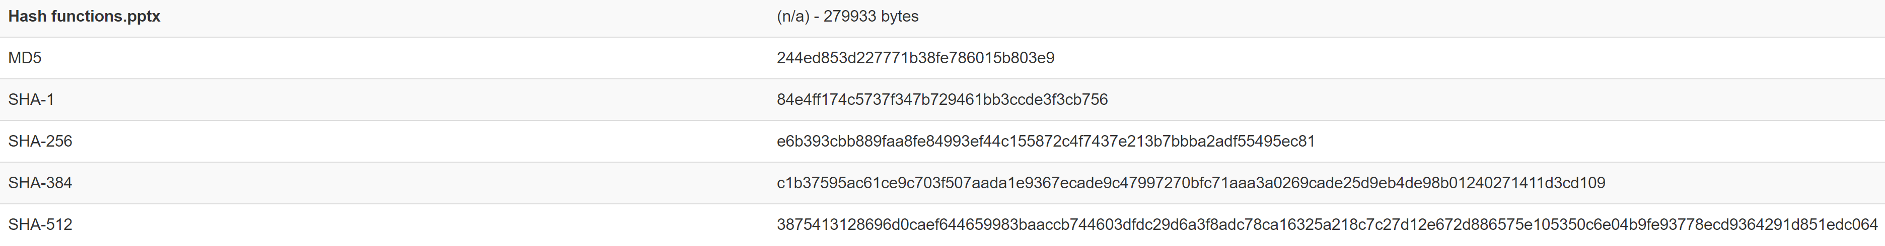

MD5: 244ed853d227771b38fe786015b803e

**Modified PowerPoint**

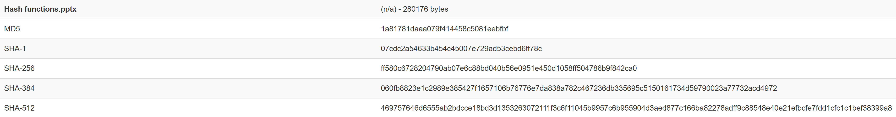

MD5: 1a81781daaa079f414458c5081eebfbf

Since there is **A CHANGE** in the Hash value, we can infer that the file has been modified.

1. **Original Image**

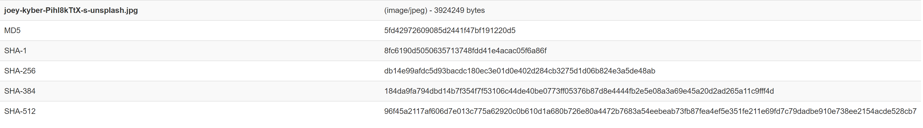

MD5: 5fd42972609085d2441f47bf191220d5

**Un-modified Image**



MD5: 5fd42972609085d2441f47bf191220d5

Since there is **NO CHANGE** in the Hash values, we can infer that the file has not been modified.

**Lab 3: File Analysis Tools**

**R. Harini**

**18BCE1010**

Algorithm / Procedure: Download and install Microsoft’s Log Parser tool for the Windows environment from Microsoft’s Web Site.

<https://www.microsoft.com/en-in/download/details.aspx?id=24659>

Tutorial Link: [Log Parser Tutorial: Learn to Parse Many Input Formats | Scalyr](https://www.scalyr.com/blog/log-parser-tutorial/)

**Output:**

1. LogParser “SELECT LogFileName as LineFromFile FROM C:\Windows\Logs\CBS\CBS.log

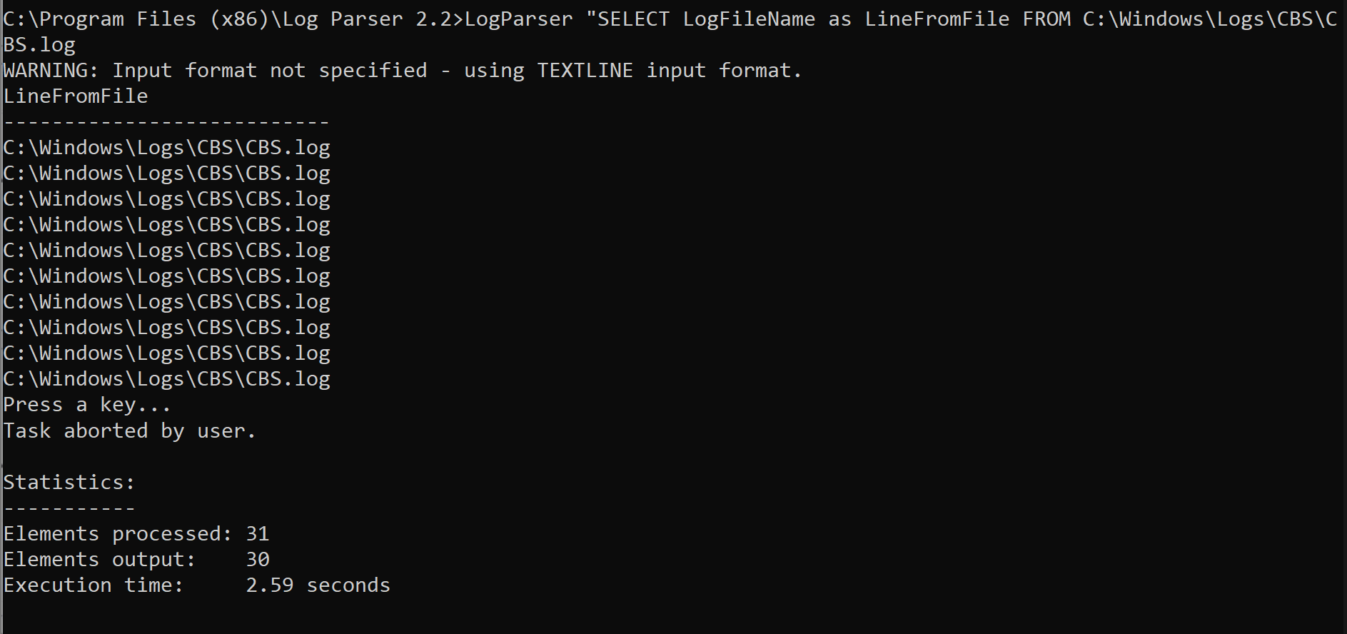

1. LogParser “SELECT Index as LineFromFile FROM C:\Windows\Logs\CBS\CBS.log

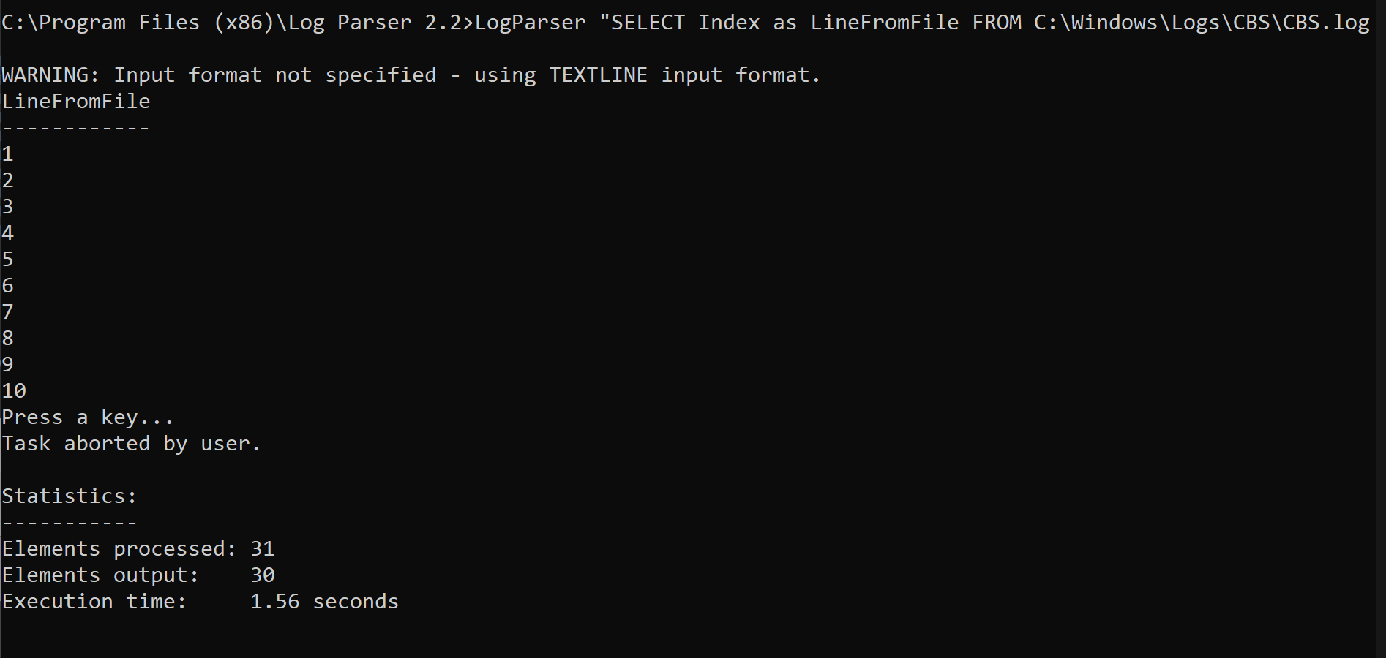

1. LogParser “SELECT Text as LineFromFile FROM C:\Windows\Logs\CBS\CBS.log

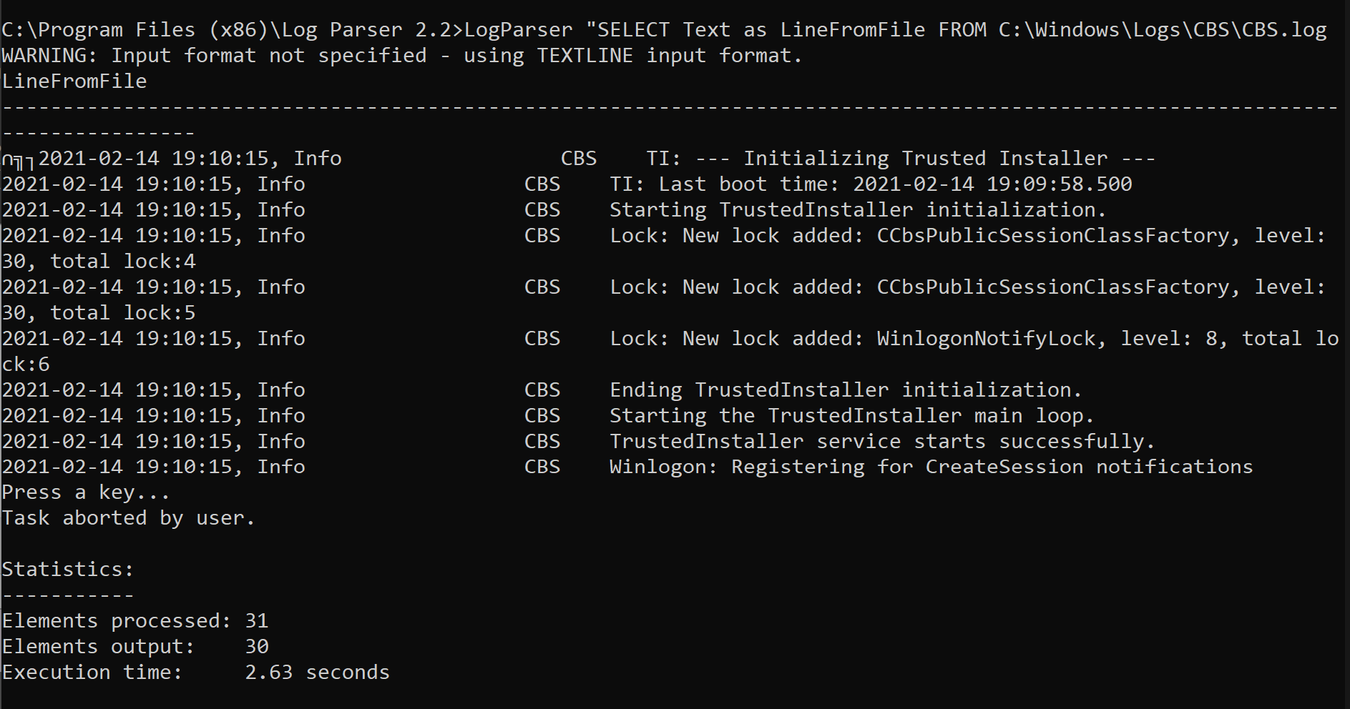

**Lab 4: Event Viewer and Event Log Explorer Tool**

**R. Harini**

**18BCE1010**

**Procedure:** Open Event Viewer tool that is inbuilt in the Windows OS

Windows Log -> Security

Click on any one Event to view its properties and Details

**Event Viewer**

1. Successful Logon

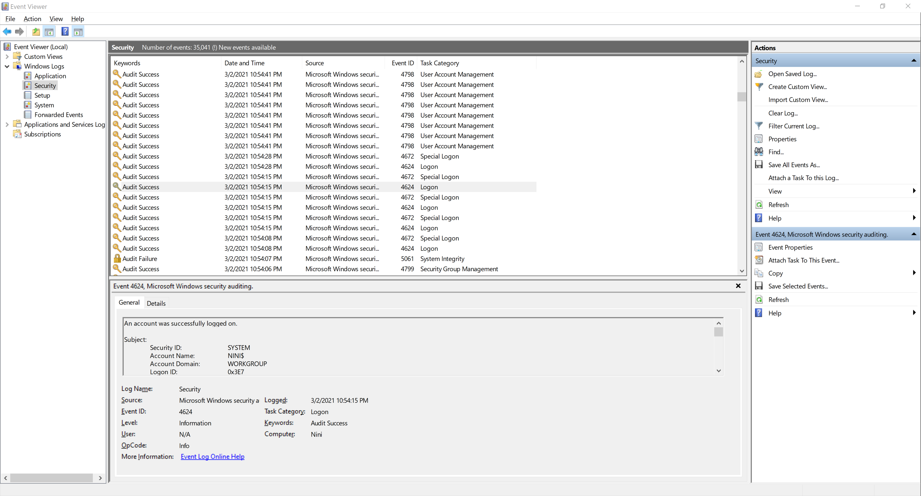

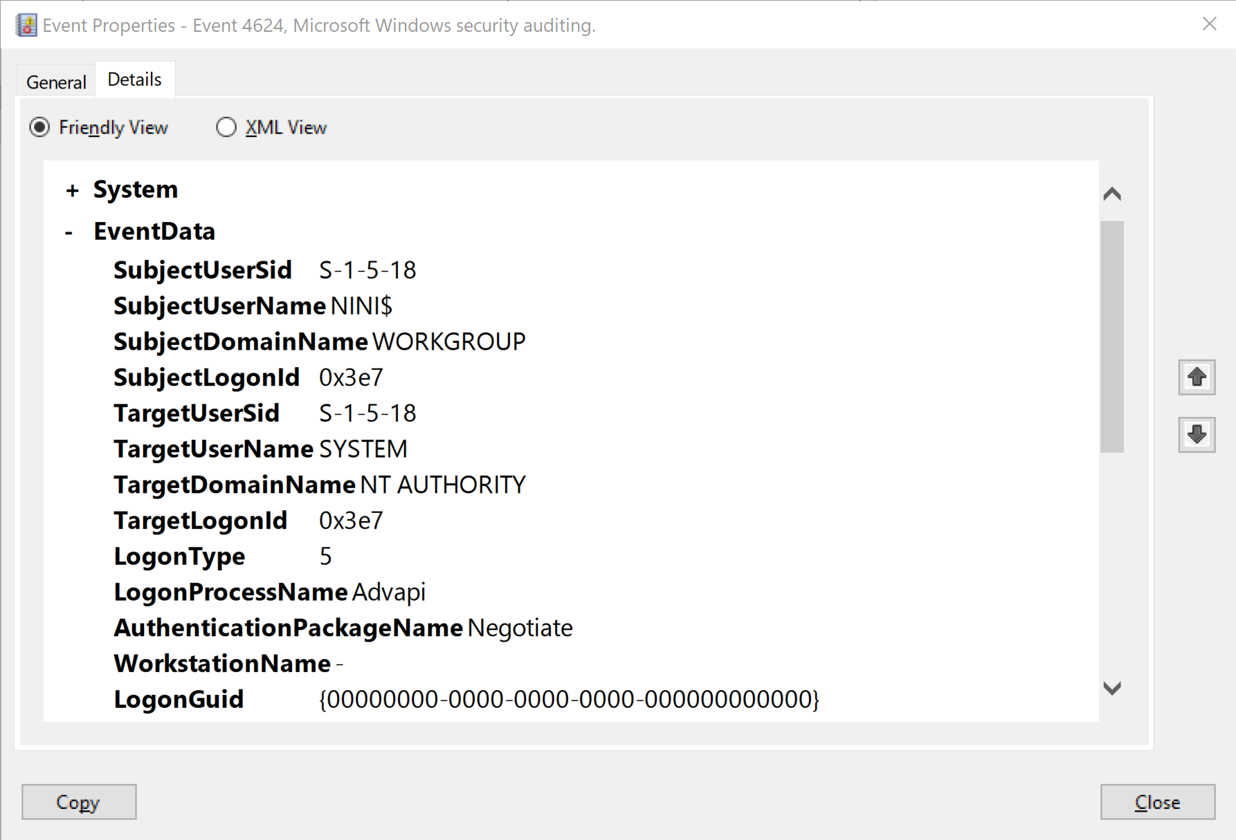

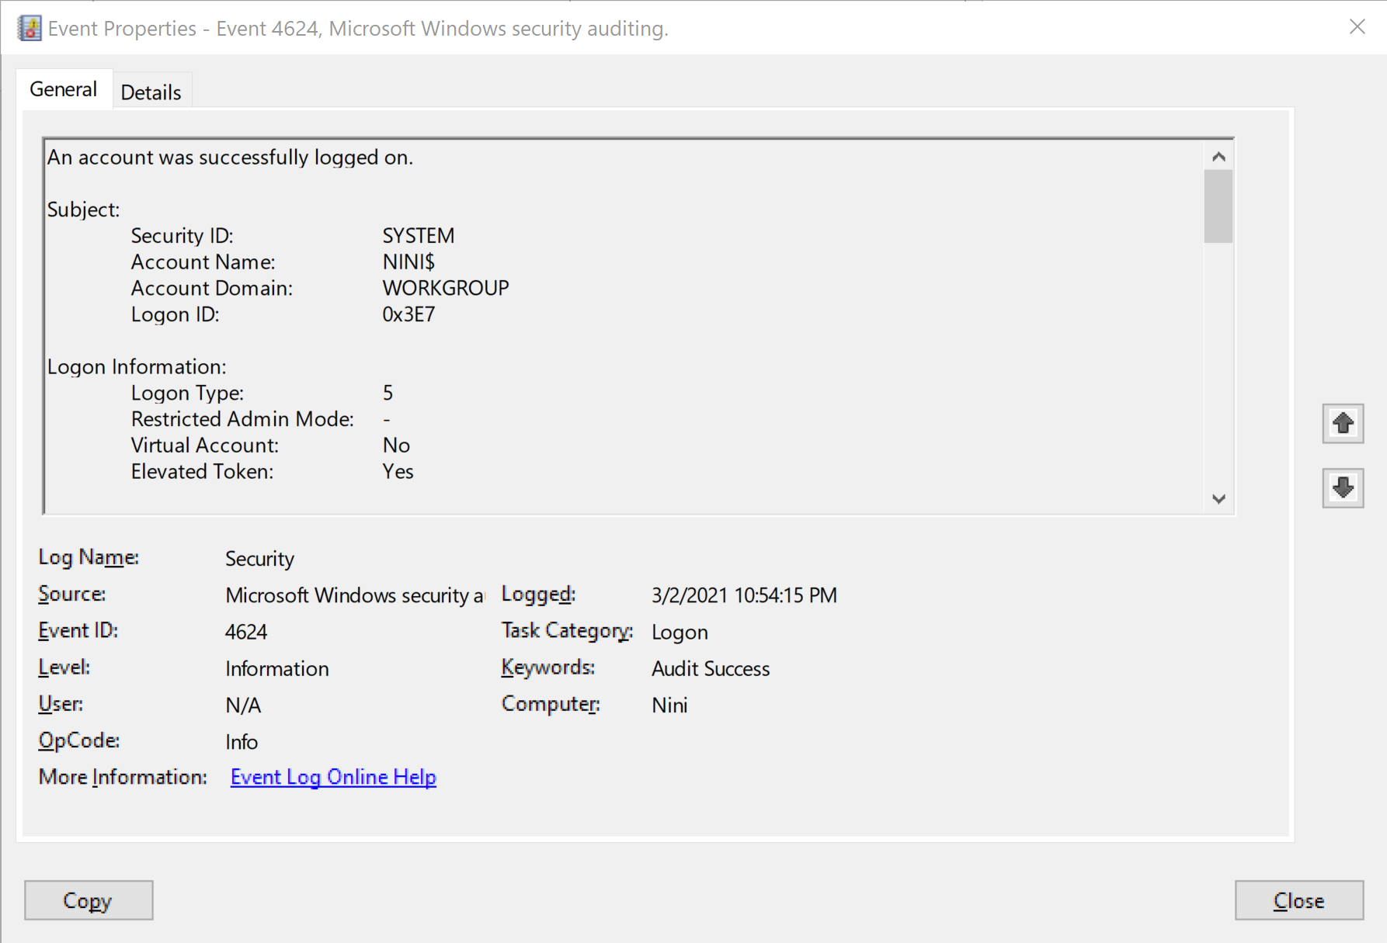

1. Failed logon

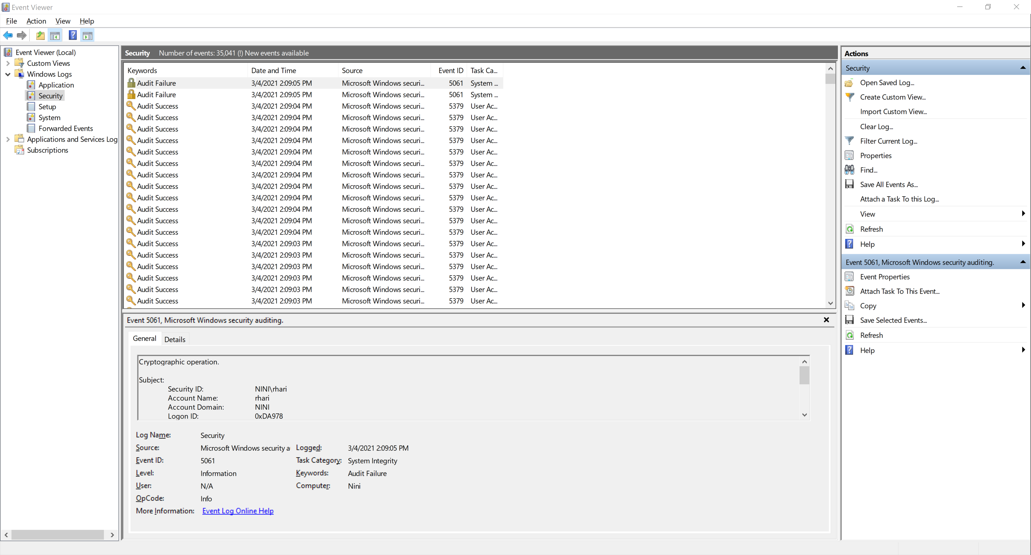

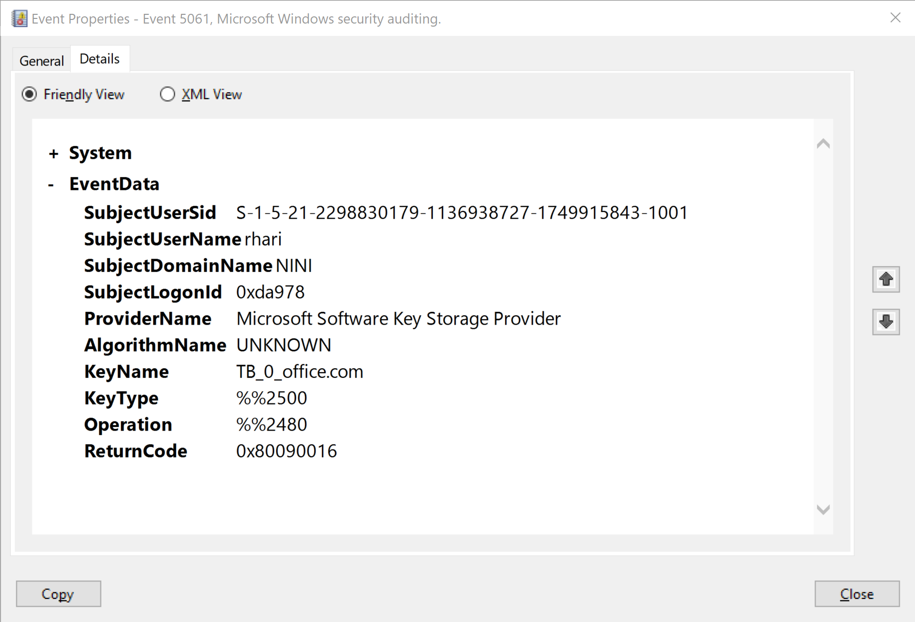

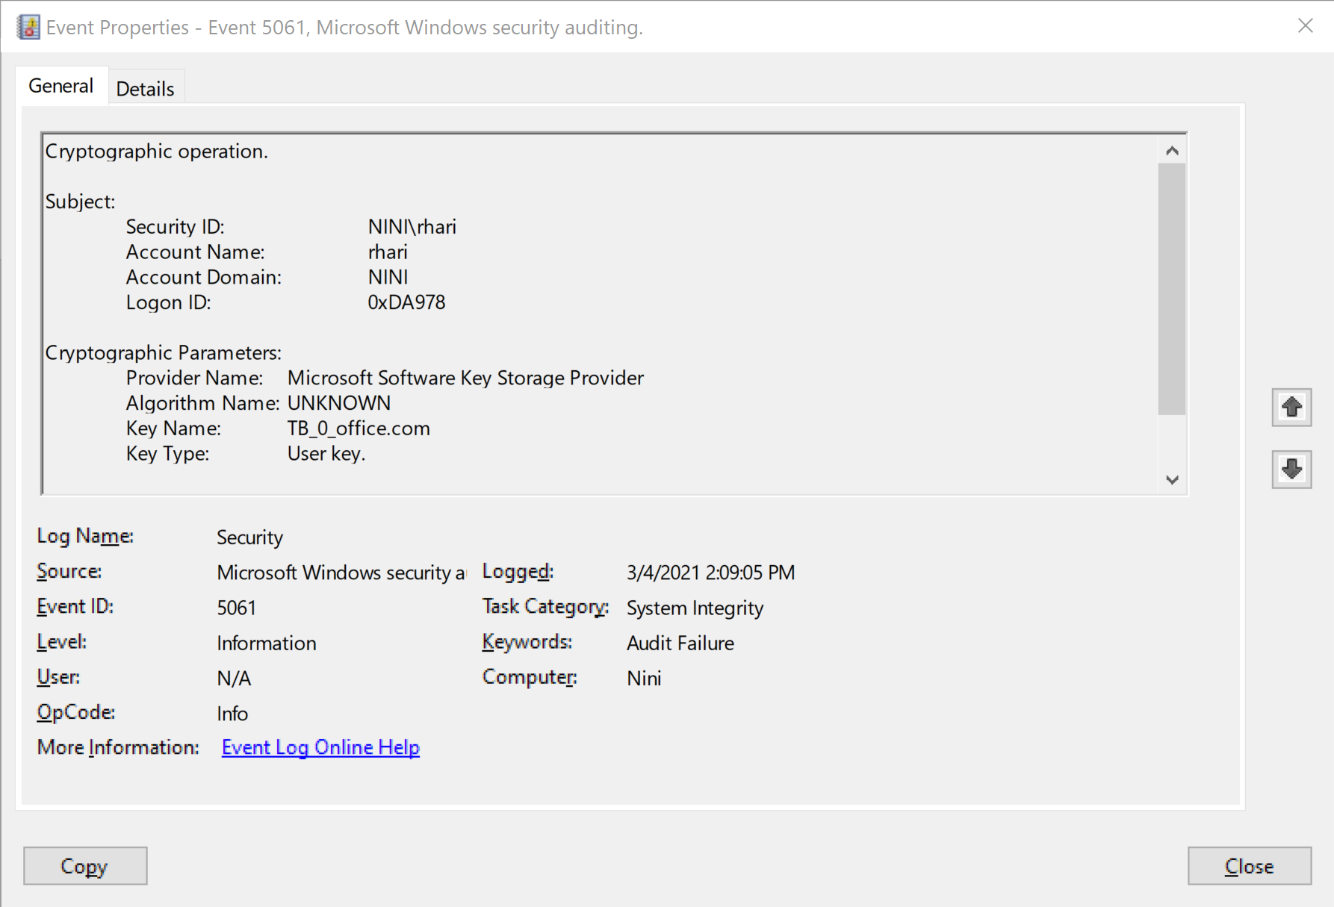

1. A new user was created

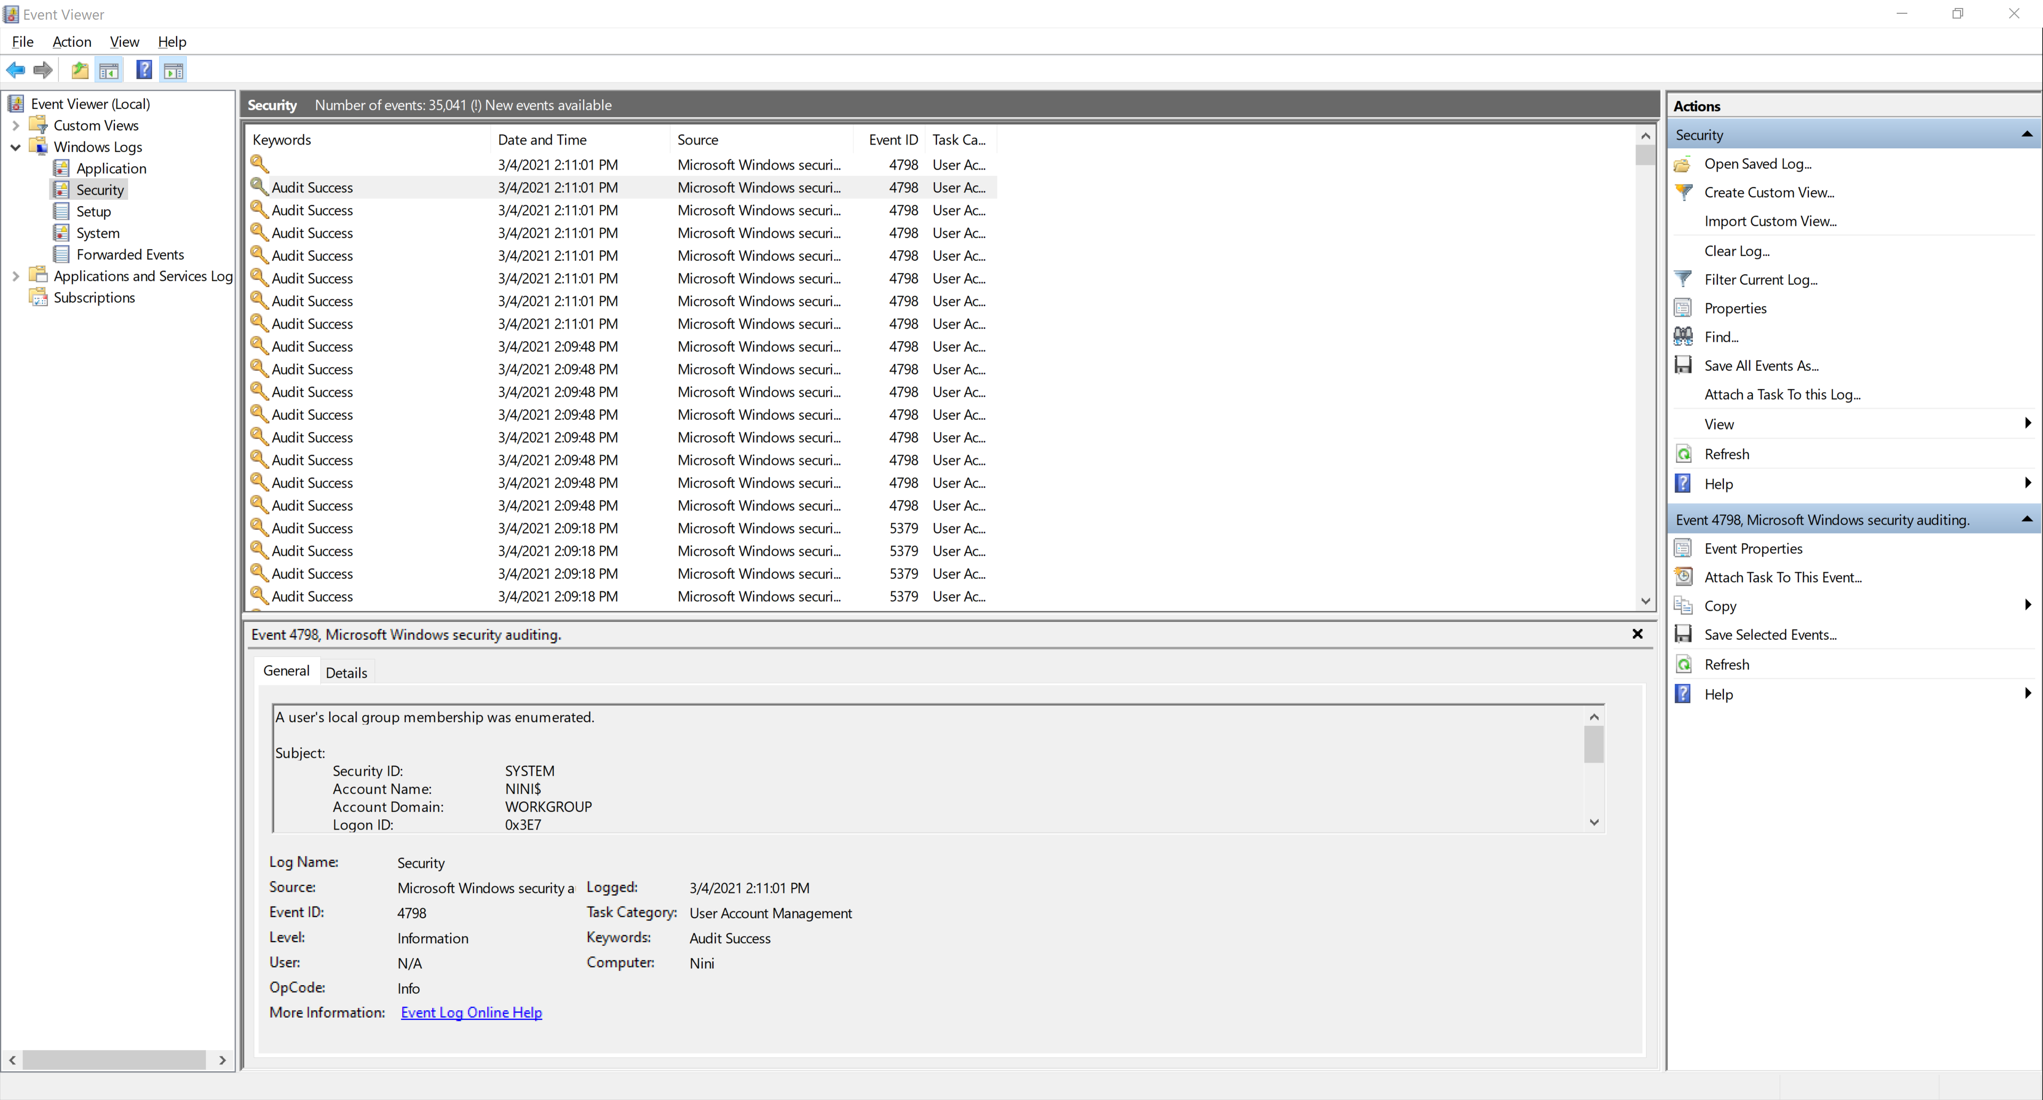

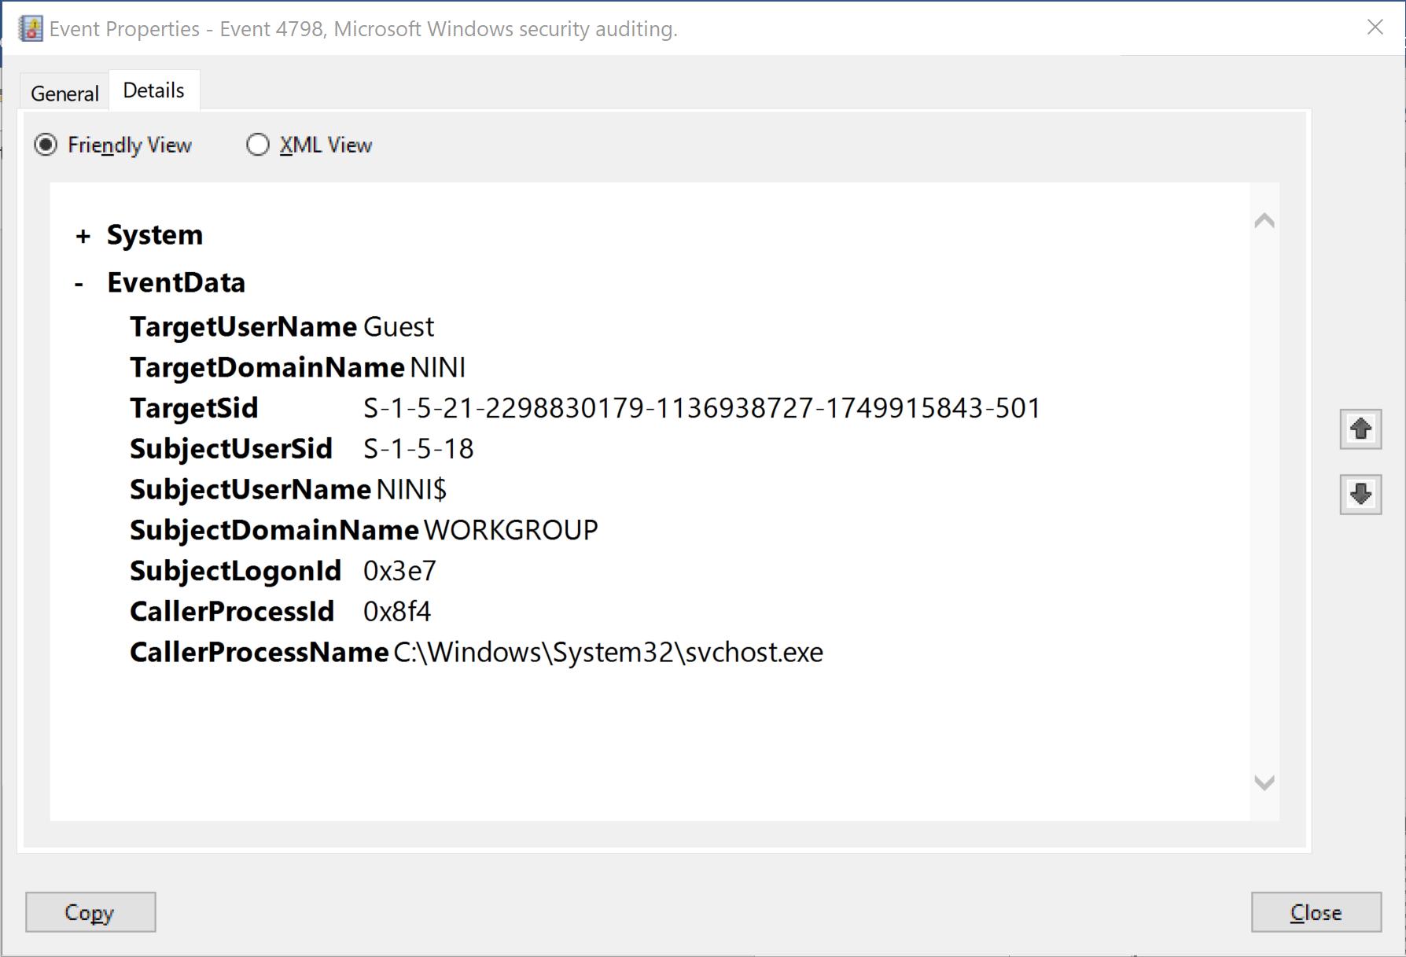

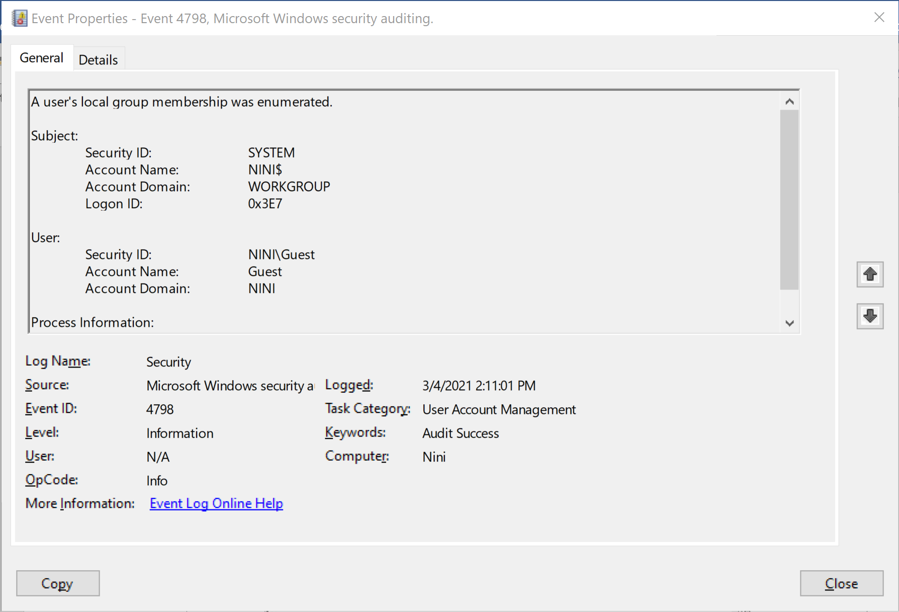

**Event Log Explorer Tool**

1. Successful Logon

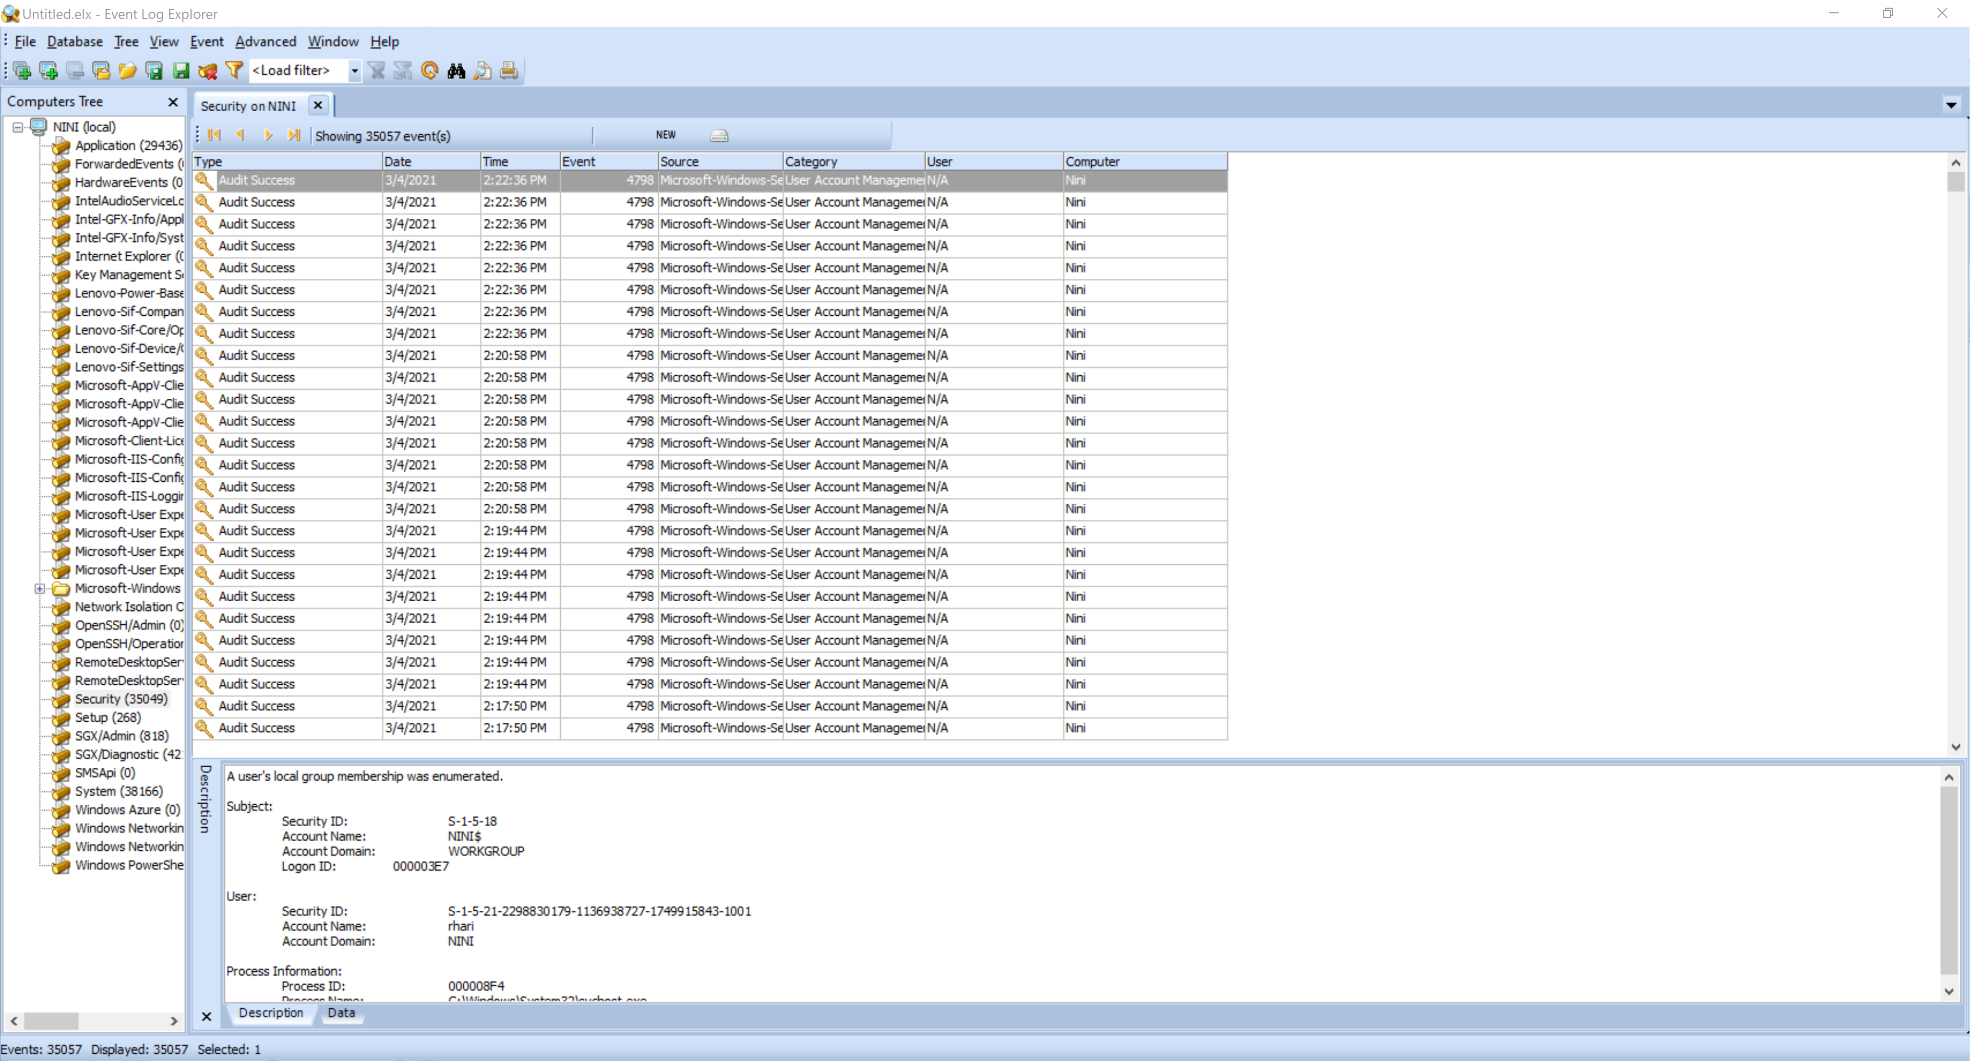

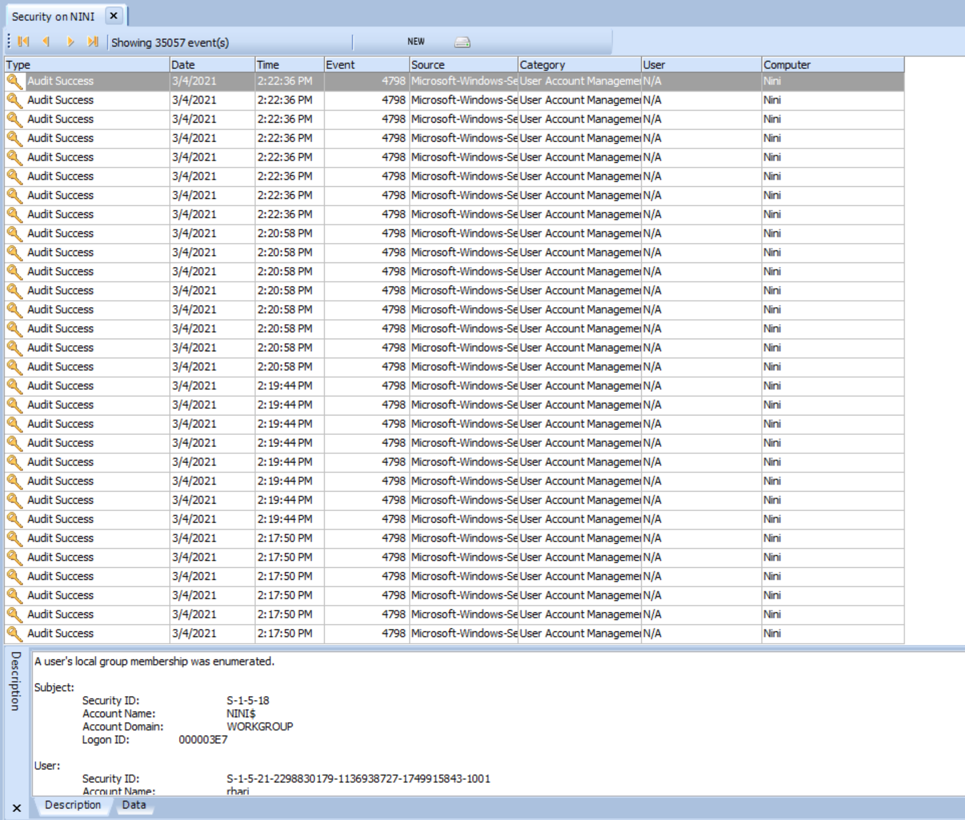

1. Failed logon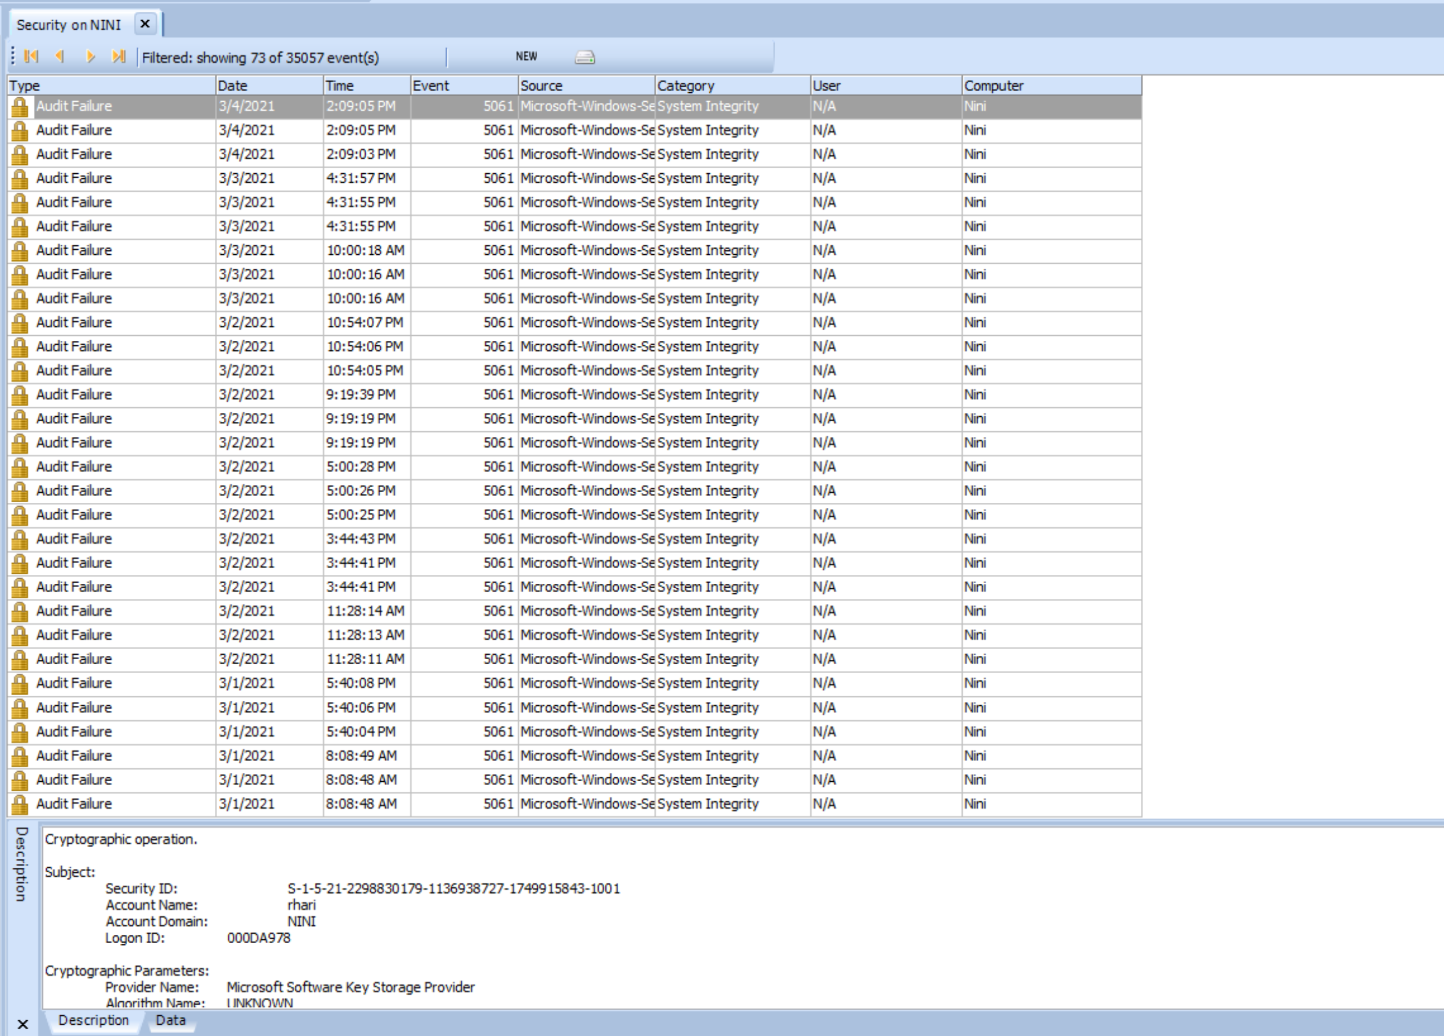

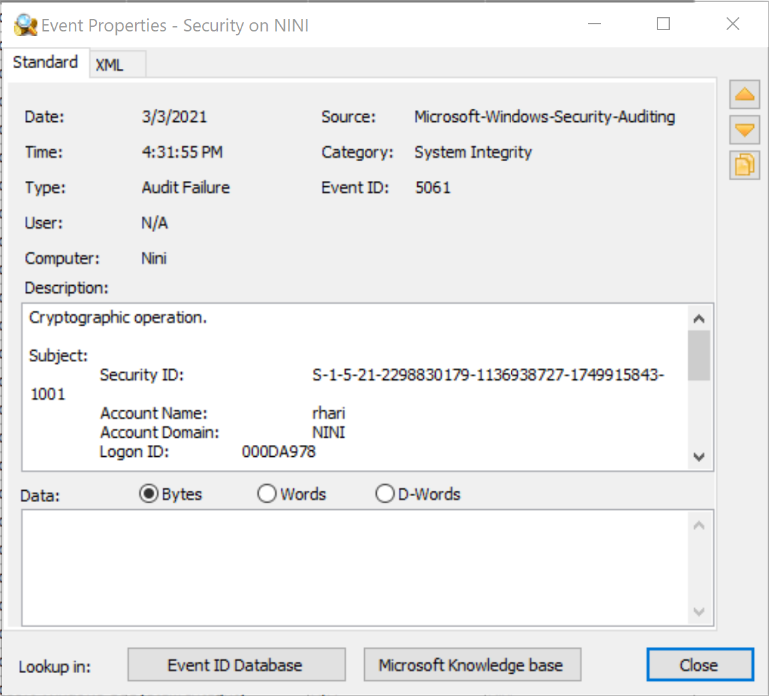

**Lab 5: Encoding and Decoding using DCode**

**R. Harini**

**18BCE1010**

1. **Using DCode Tool**

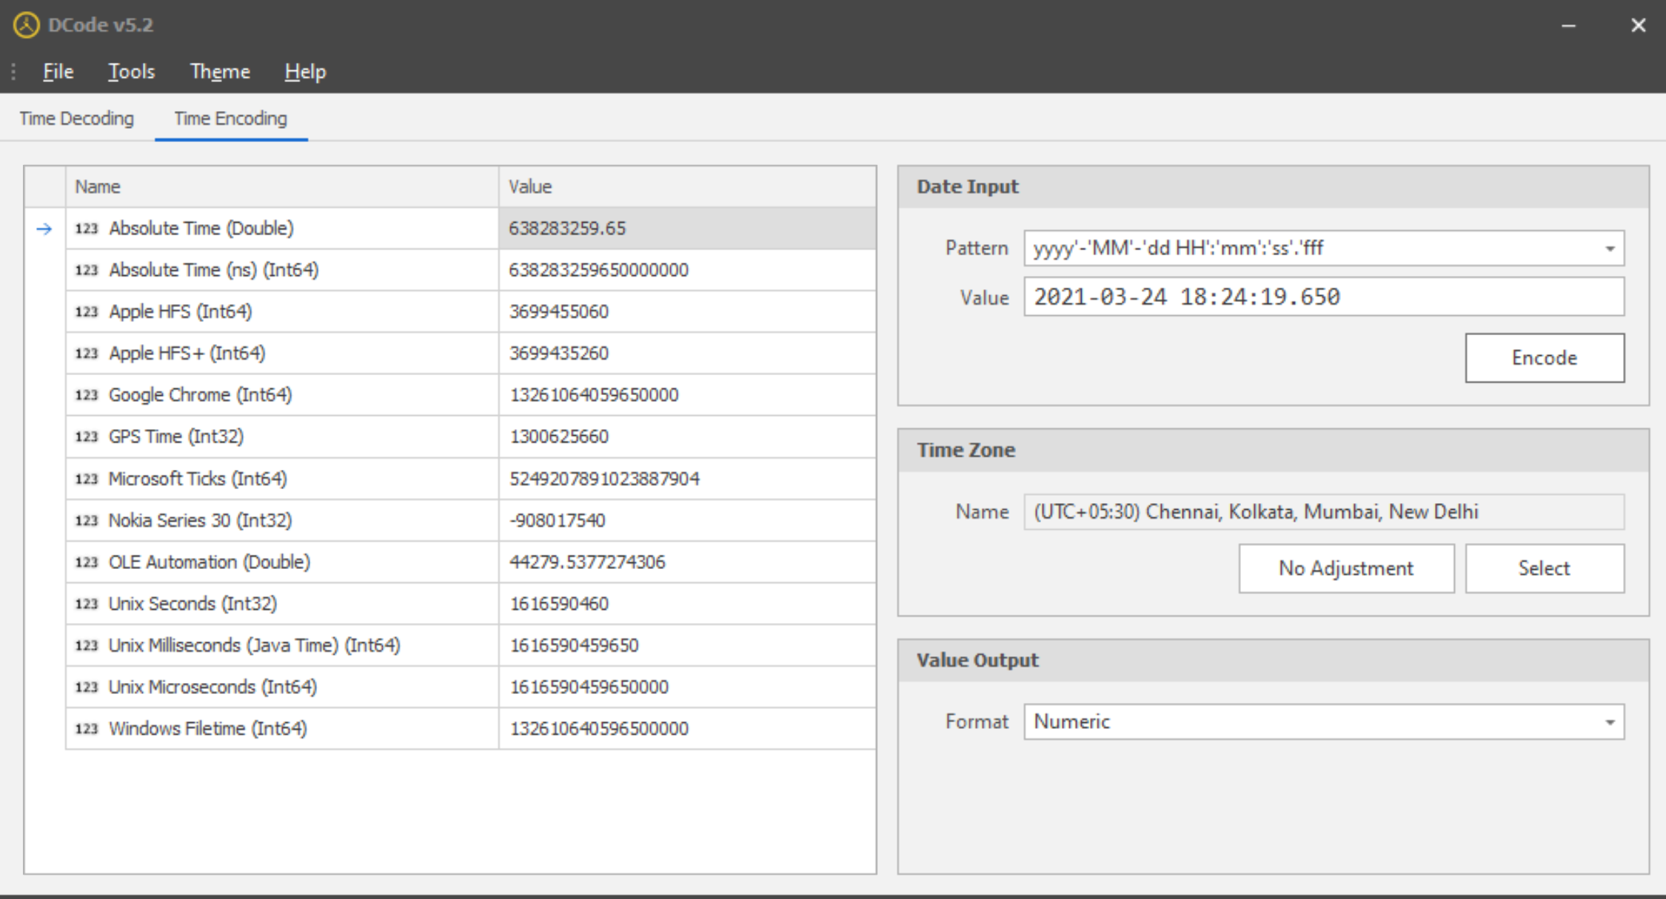

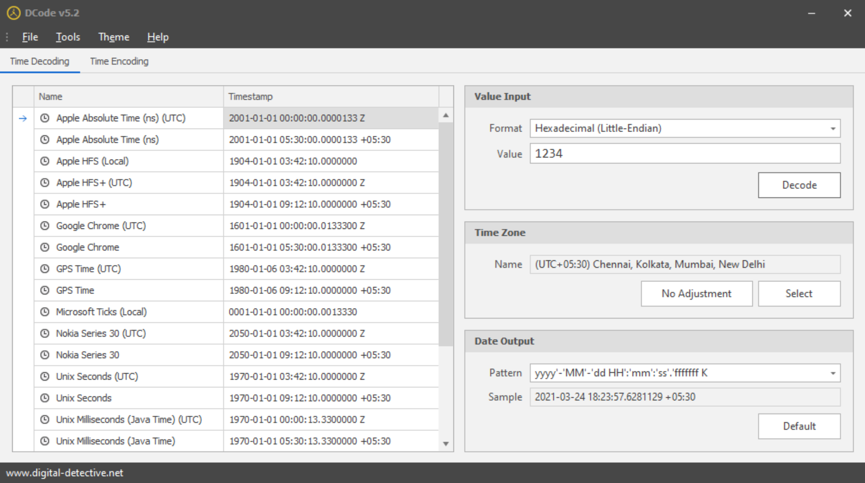

1. **Using String.exe**

**Procedure:**

Open cmd

Navigate to the path with the .docx file

Type **strings <filename>.docx**

**Output:**

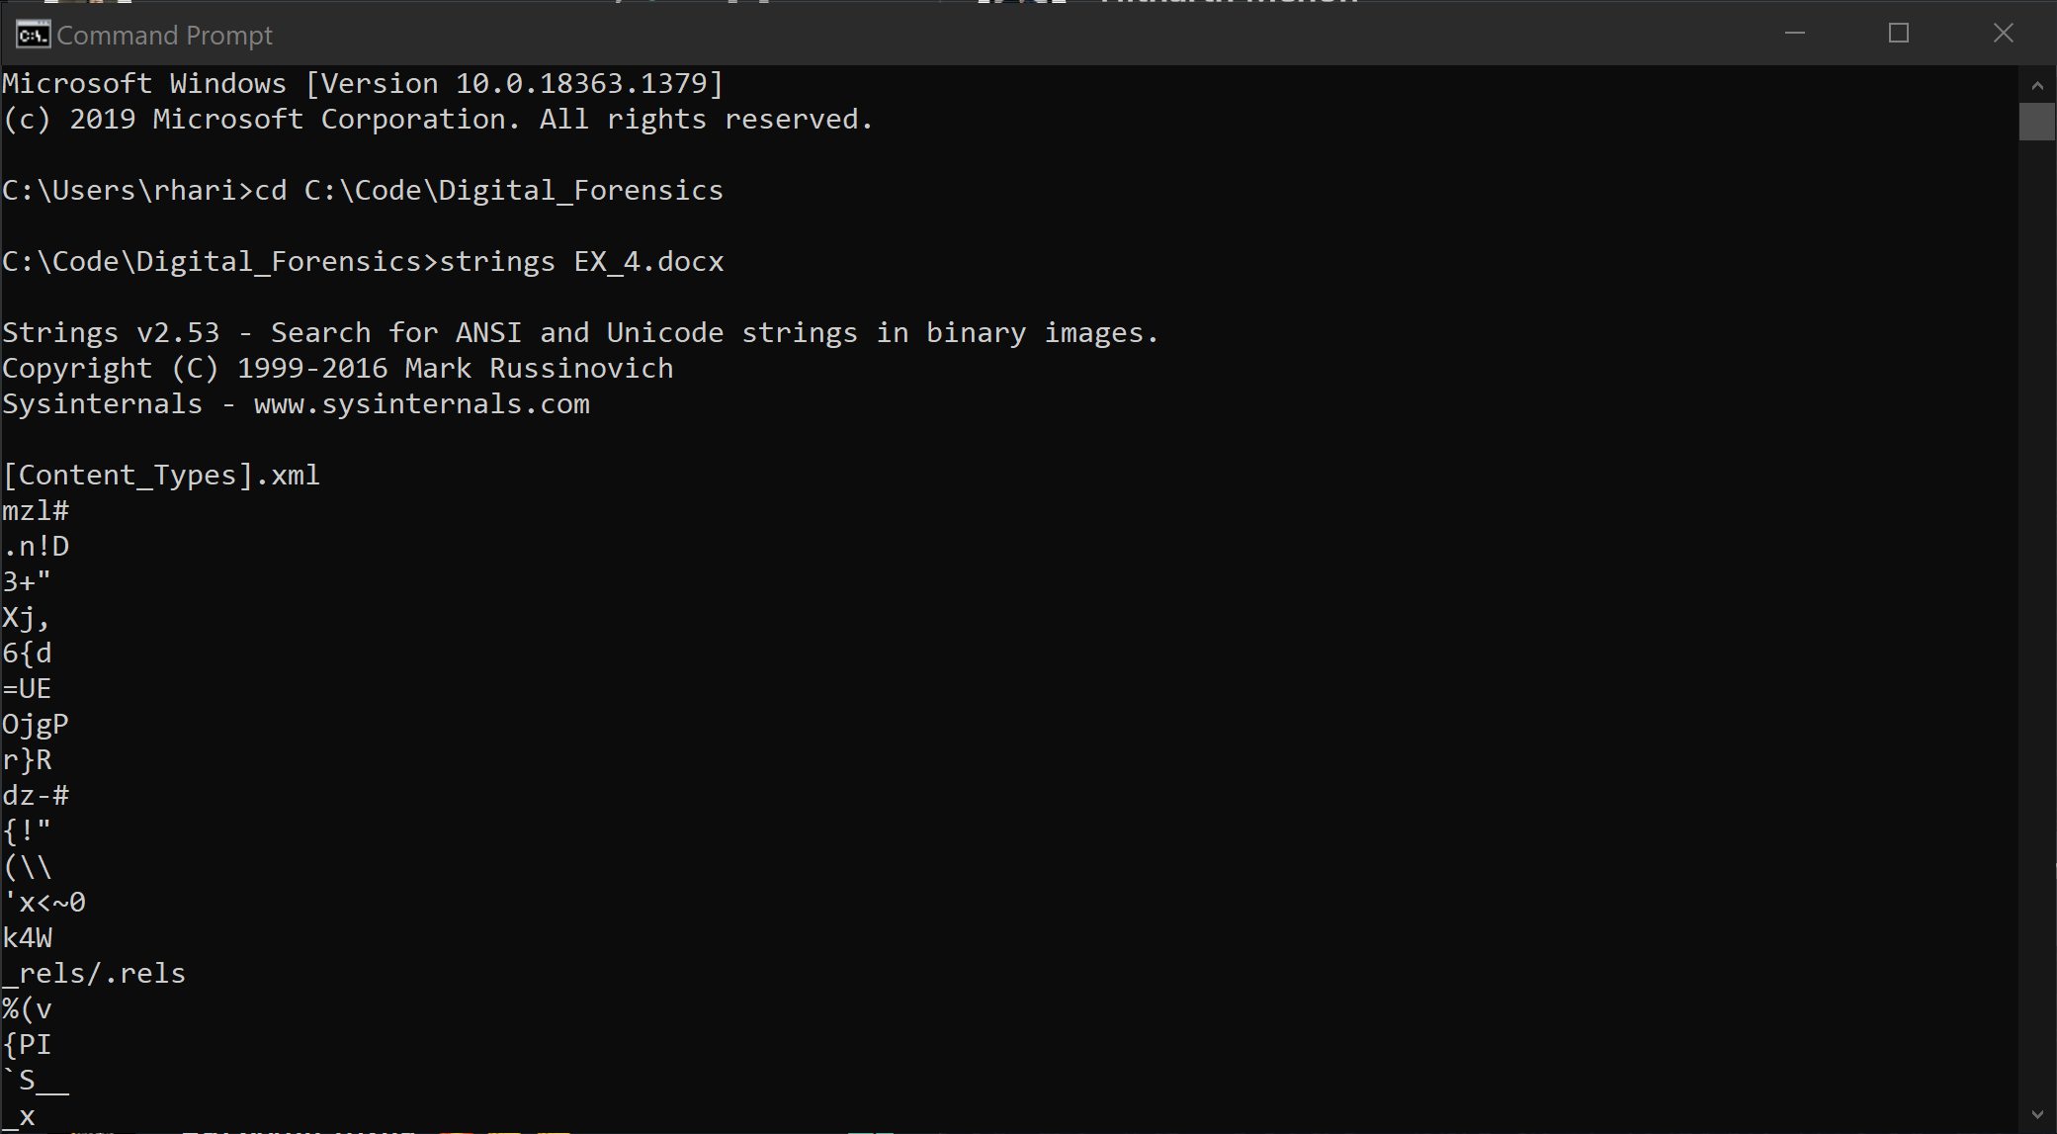

**Lab 6: Using Windows CMD line**

**R. Harini**

**18BCE1010**

**Aim:** To become familiar with the Windows command line for digital forensics investigations

1. **Use commands to find the IPv4 address and subnet mask of your computer.**

**Procedure:** Using ipconfig command

IPv4: 172.17.136.177

Subnet mask: 255.255.255.240

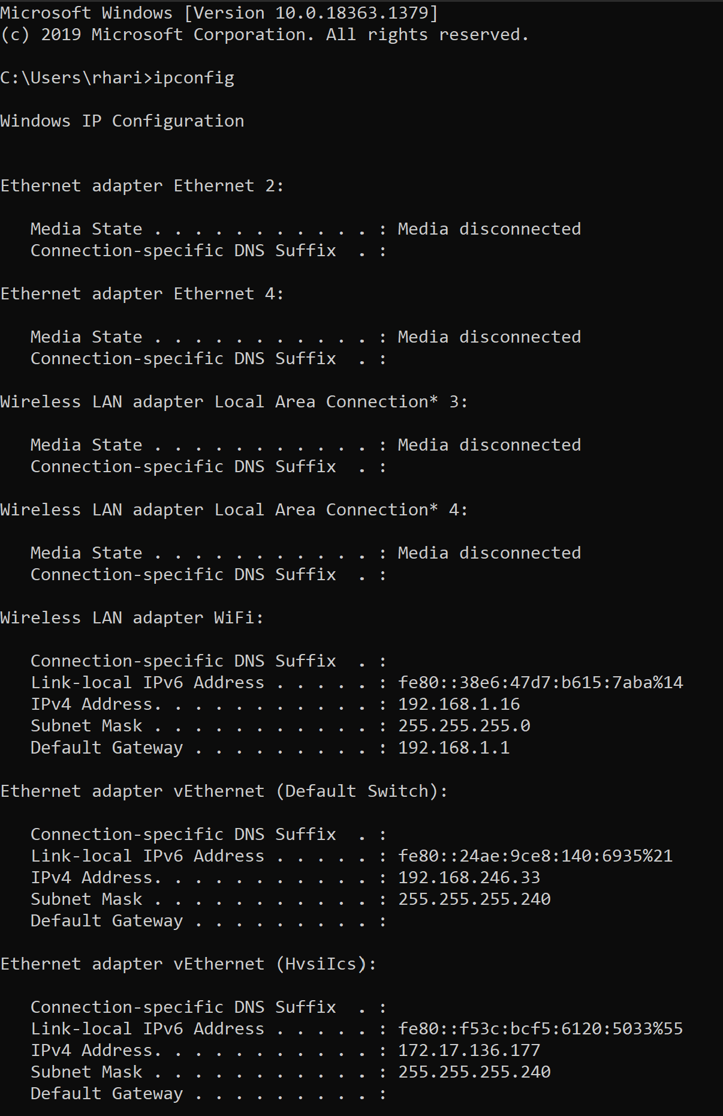

1. **Create a batch file that will capture the following volatile information from an evidence system and store it in a file.**

**Code:**

@echo off

FOR /F "delims=: tokens=2" %%a in ('ipconfig ^| find "IPv4"') do set _IPAddress=%%a

ECHO IP address is: %_IPAddress% >> grv.txt

For /f "tokens=2-4 delims=/ " %%a in ('date /t') do (set mydate=%%c-%%a-%%b)

For /f "tokens=1-2 delims=/:" %%a in ('time /t') do (set mytime=%%a%%b)

echo Date: %mydate% >>grv.txt

echo Time: %mytime% >>grv.txt

echo. >>grv.txt

echo ARP Table >>grv.txt

FOR /L %%A IN (1,1,5) DO (

arp -a | findstr 20-7c-8f-3f-03-9c

cls

if %errorlevel% GEQ 1 (

echo The device is offline

Echo Device is offline at %time% on %date%. >> grv.txt

) else (

echo The device is online.

Echo Device is online at %time% on %date%. >> grv.txt

)

timeout 3 >nul /nobreak

)

echo. >>grv.txt

echo Network Connection Information >>grv.txt

netstat -a>>grv.txt

**Screenshots:**

